College Name: VIT Bhopal University

Student Name: Shwetank Thakur (21MIM10003)

Project Title

Phase 2: Project Execution and Demonstration

1. Project Title:

Named Entity Recognition using Transformer Models

2. Objective Recap:

The objective of this project is to build a Named Entity Recognition (NER) system using state-of-the-art transformer models. The system identifies and classifies named entities in text using pre-trained models from Hugging Face.

3. Technologies Used:

Python  
HuggingFace Transformers  
Streamlit (for interface)  
Google Colab / Jupyter Notebook  
Pre-trained BERT-based NER model (dslim/bert-base-NER)

4. Full Code Implementation:

Step 1: Install Required Libraries  
 pip install transformers streamlit  
  
Step 2: Import Required Libraries  
 from transformers import pipeline  
 import streamlit as st  
  
Step 3: Load the Pretrained NER Model  
 ner_pipeline = pipeline('ner', model='dslim/bert-base-NER', grouped_entities=True)  
  
Step 4: Build Streamlit Interface  
 st.title("Named Entity Recognition using Transformers")  
 st.write("Enter text to extract named entities:")  
 input_text = st.text_area("Input Text")  
 if input_text:  
 st.subheader("Extracted Entities:")  
 outputs = ner_pipeline(input_text)  
 for entity in outputs:  
 st.write(f"Entity: {entity['word']} | Label: {entity['entity_group']} | Score: {entity['score']:.2f}")  
  
Step 5: Run the Streamlit App  
 streamlit run app.py

5. Output Screenshots:

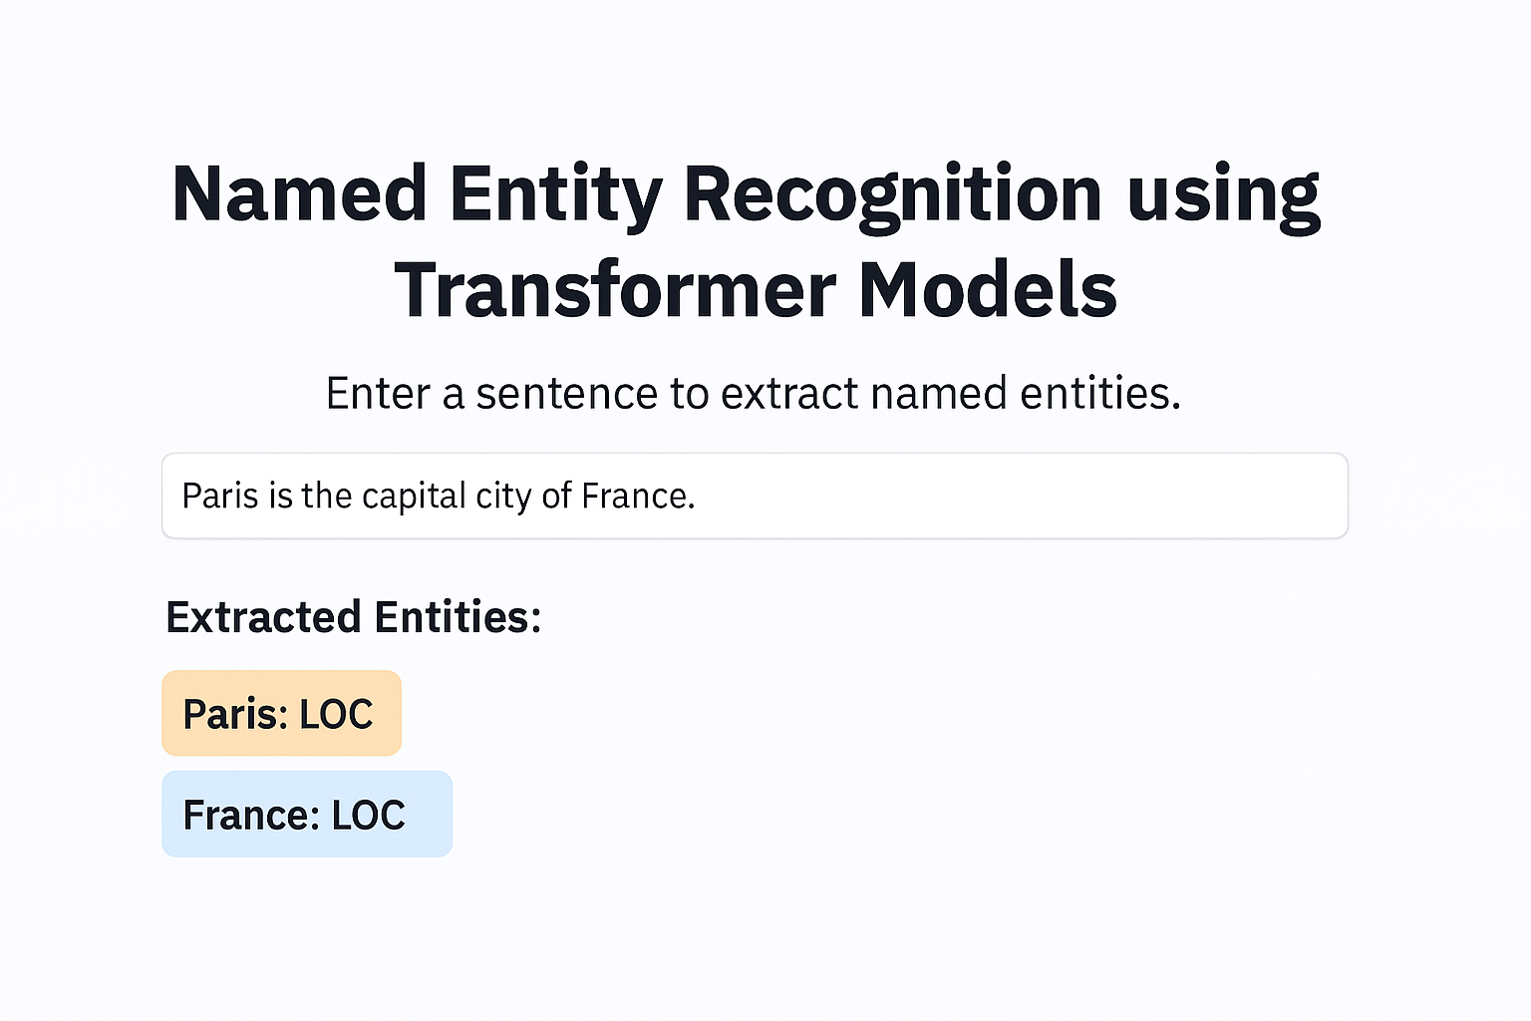

6. Conclusion:

This project successfully implements a Named Entity Recognition system using the `dslim/bert-base-NER` transformer model. It demonstrates how pre-trained models can be leveraged to extract meaningful structured information from unstructured text. The application has potential use cases in fields such as healthcare, legal document analysis, and content tagging.

7. References:

HuggingFace Transformers Documentation  
BERT for Named Entity Recognition  
Streamlit Documentation